**Batch: A3 Roll No.: 16010121045**

**Experiment / assignment / tutorial No. 4**

**Grade: AA / AB / BB / BC / CC / CD /DD**

**Signature of the Staff In-charge with date**

|  |
| --- |
| **Title:**  Implementation of Stack applications. |

**Objective:** To implement applications of stack

**Expected Outcome of Experiment:**

|  |  |
| --- | --- |
| **CO** | **Outcome** |
| 1 | Explain the different data structures used in problem solving |

**Books/ Journals/ Websites referred:**

1. *Fundamentals Of Data Structures In C –* Ellis Horowitz, Satraj Sahni, Susan Anderson-Fred
2. *An Introduction to data structures with applications –* Jean Paul Tremblay,

Paul G. Sorenson

1. *Data Structures A Pseudo Approach with C –* Richard F. Gilberg & Behrouz A. Forouzan
2. [*https://www.cprogramming.com/tutorial/computersciencetheory/stack.html*](https://www.cprogramming.com/tutorial/computersciencetheory/stack.html)
3. [*https://www.geeksforgeeks.org/stack-data-structure-introduction-program/*](https://www.geeksforgeeks.org/stack-data-structure-introduction-program/)
4. [*https://www.thecrazyprogrammer.com/2013/12/c-program-for-array-representation-of-stack-push-pop-display.html*](https://www.thecrazyprogrammer.com/2013/12/c-program-for-array-representation-of-stack-push-pop-display.html)

**Assigned Stack application**: Static, Undo-Redo operations

**Algorithm:**

* Start
* Initialize two stacks, say Stack and Backup-stack.
* Traverse the array of strings, Q, and perform the following operations:
* If Add data is selected then, push the character to Undo stack
* If Undo data is selected then, pop the top element from main stack and push it to backup stack.
* If Redo data is selected then, pop the top element of backup stack and push it into the main stack.
* If display data is selected then, print all the elements of the main stack.

**Example:**

* Perform Write P in the data. Therefore, the data contains only “P”.
* Perform Write A on the data. Therefore, the data contains “PA”.
* Perform Write R on the data. Therefore, the data contains “PAR”.
* Perform Undo on the data. Therefore, the data contains “PA”.
* Print the contents of the data, i.e. “PA”
* Perform Redo on the data. Therefore, the data contains “PAR”.
* Print the contents of the data, i.e. “PAR”

**Source code:**

*#include* <stdio.h>

void push(char \**arr*, char *ele*, int *n*, int \**top*)

{

*if* (*top >= n - 1)

printf("The Stack is Full\n");

*else*

{

*top = *top + 1;

arr[*top] = ele;

}

}

char pop(char \**arr*, int \**top*)

{

*if* (*top != -1)

{

int temp = arr[*top];

arr[*top] = 0;

*top = *top - 1;

*return* (temp);

}

printf("The Stack is Empty\n");

*return* ('@');

}

char peek(char \**arr*, int \**top*)

{

*return* (arr[*top]);

}

void printStack(char \**arr*, int \**top*)

{

*for* (int i = *top; i > -1; i--)

printf("%c\n", arr[i]);

}

int main()

{

int n;

printf("Enter Opperation size: ");

scanf("%d", &n);

char stack[n], bstack[n];

int top = -1, btop = -1;

int j = -1;

*while* (j != 5)

{

printf("\n\n(1) Add Data\n");

printf("(2) Undo\n");

printf("(3) Redo\n");

printf("(4) View Data\n");

printf("(5) Exit\n");

printf("Select an option: ");

scanf("%d", &j);

*if* (j == 1)

{

char ele;

printf("\nEnter Data: ");

scanf(" %c", &ele);

push(stack, ele, n, &top);

}

*else* *if* (j == 2)

{

char temp = pop(stack, &top);

*if* (temp != '@')

{

push(bstack, temp, n, &btop);

printf("Element %c is removed\n", temp);

*if* (peek(stack, &top) == '@')

printf("There is no next data!\n");

*else*

printf("Next data is %c", peek(stack, &top));

}

}

*else* *if* (j == 3)

{

char temp = pop(bstack, &btop);

*if*(temp !='@'){

push(stack, temp, n, &top);

printf("Element %c is added back!\n", temp);

}

}

*else* *if* (j == 4)

printStack(stack, &top);

*else* *if* (j == 5)

*break*;

*else*

printf("Please Enter correct option\n");

}

*return* 0;

}

**Output Screenshots:**

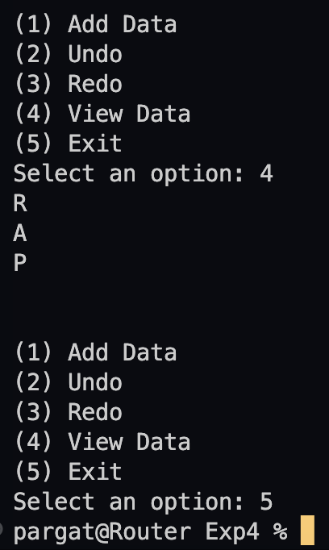

**Conclusion:**

Successfully implemented Undo-Redo operation implementation using static stack.